**Algorithmic Digital Marketing**

|  |  |
| --- | --- |
| **Summary** | In this codelab, you’ll build a Progressive Web App, which loads quickly, even on flaky networks, has an icon on the homescreen, and loads as a top-level, full screen experience. |
| **URL** | [https://www.nike.com](https://www.nike.com/) |
| **Category** | Web |

About Nike

Products available on this site

The way they are selling

How is it priced?

What promotions are they using?

What algorithmic marketing services are they using?

What datasets do you think you will need to build these algorithmic services?

How would you store these datasets?

After review of the site, what technologies and programmatic services is the company using?

How is the company tracking visitors?

# **About Nike**

Nike is an American [multinational corporation](https://en.wikipedia.org/wiki/Multinational_corporation) that is engaged in the design, development, manufacturing, and worldwide marketing and sales of footwear, apparel, equipment, accessories, and services. The company was founded on January 25, 1964, as Blue Ribbon Sports, by [Bill Bowerman](https://en.wikipedia.org/wiki/Bill_Bowerman) and [Phil Knight](https://en.wikipedia.org/wiki/Phil_Knight), and officially became Nike, Inc. on May 30, 1971. It is headquartered near [Beaverton](https://en.wikipedia.org/wiki/Beaverton,_Oregon), [Oregon](https://en.wikipedia.org/wiki/Oregon), in the [Portland metropolitan area](https://en.wikipedia.org/wiki/Portland_metropolitan_area). It is the world's largest supplier of [athletic shoes](https://en.wikipedia.org/wiki/Sneakers) and [appare](https://en.wikipedia.org/wiki/Clothing)l and a major manufacturer of [sports equipment](https://en.wikipedia.org/wiki/Sports_equipment), with revenue in excess of US$24.1 billion in its fiscal year 2012. Nike ranked No. 89 in the 2018 [Fortune 500](https://en.wikipedia.org/wiki/Fortune_500) list of the largest United States corporations by total revenue.

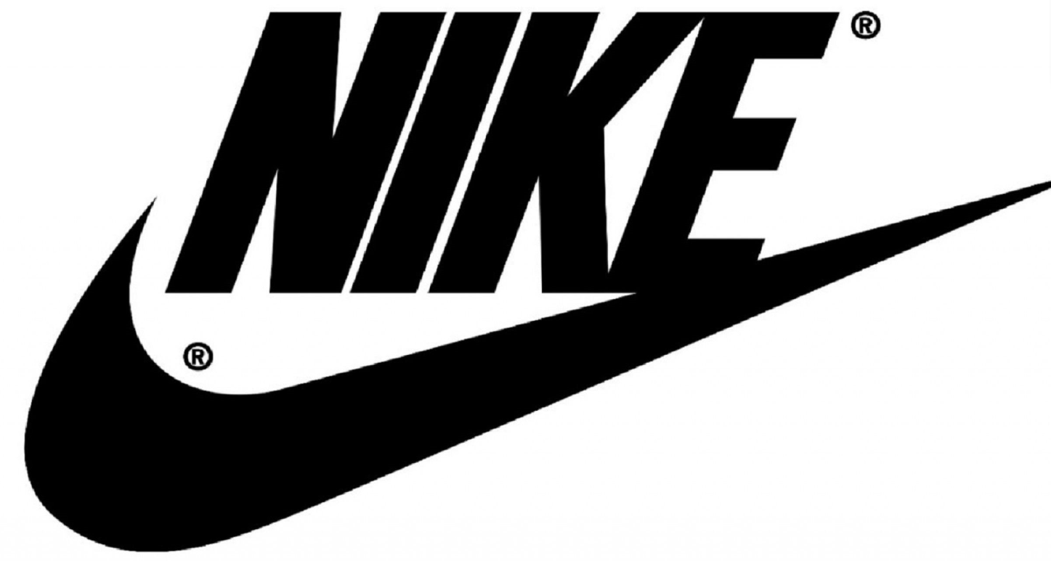

# **Products available on this site**

The products which are available on Nike website can be broadly categorized based on gender and age. It has different categories for different genders and a seperate section for kids as well.

The different categories on the available are:

**Men**

* Shoes
* Clothing
* Accessories and Equipment

**Women**

* Shoes
* Clothing
* Accessories and Equipment

**Kids**

* Boys Shoes
* Boys Clothing
* Girls Shoes
* Girls Clothing

The site also provides different sections to customize the products based on the customers choice and also a section which shows the new releases which the company has made**.**

# **The way they are selling**

Nike spends over $3 Billion in advertising a year. They promote their products with celebrities, professional and college athletes with sponsorship agreements. Nike also invested in marketing early on in their establishment. Nike focuses on sponsorships, internet marketing, email marketing, and utilized multimedia marketing campaigns.

Some examples of Nike's Sponsorships are:

* Golf - Tiger Woods
* Basketball - Michael Jordan, Lebron James, and Kobe Bryant
* Baseball - Albert Pujols and Joe Mauer
* Soccer - Ronaldinho and Cristiano Ronaldo
* Tennis - Roger Federer and Serena Williams

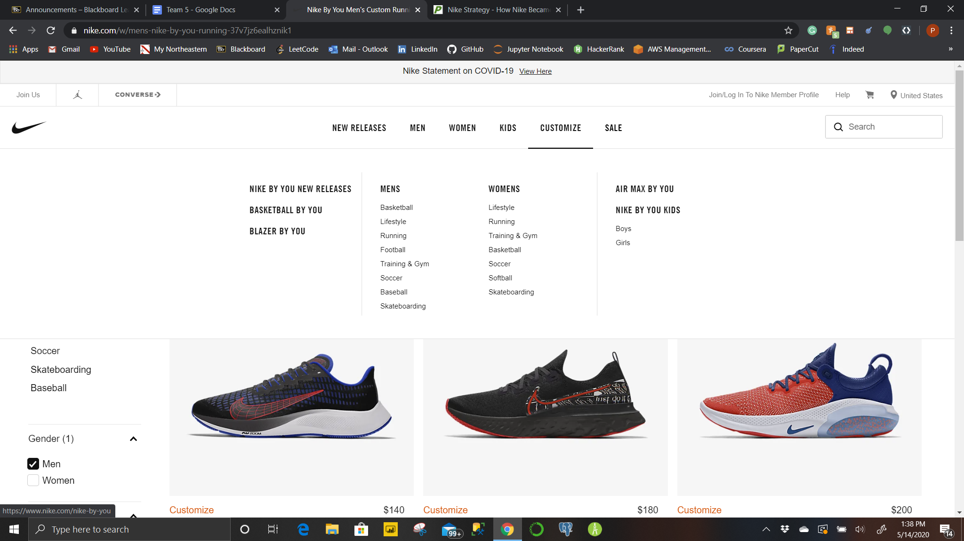

**Nike Focuses on Selling the "Emotional Benefits" of their Product**

Nike sells a lifestyle, it taps into an emotional part of the consumer that wants to aspire to live healthier and to find their own "greatness". It is noted that Bill Bowerman did not sell his shoes with his marketing strategy, but the emotional benefits of feeling good about jogging and healthy living. One writer observed that Nike mentions their product minimally in their advertisements, but focuses on the benefits of exercise.

Points to be noted:

1.No company in the world spends as much money on sports sponsorships as Nike

2.It is noted that Nike owns 48% of the athletic footwear market in the United States.

# **How is it priced?**

Pricing of the products depends on various factors:

* Based on type of sports i.e Running, Soccer, Baseball etc
* Type of brand i.e Nike, Jordan, NikeLab etc
* Different color, few colors are priced higher than normal colors
* New releases are always priced higher
* Based on country the price of the product varies

# **What promotions are they using?**

* When the customer visits the website they are prompted with a discount of up to 40% on latest styles
* They are also given an option to become a Nike member which will make them eligible for free shipping and 60-day free returns option
* They are also promoting Jordan products through their website as well as the icon clash collections
* They are also giving Nike Training Club Premium free to all their Nike Members

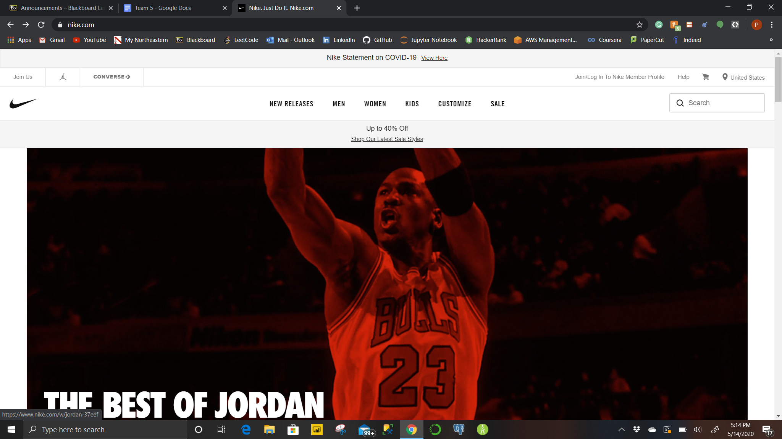

# **What algorithmic marketing services are they using?**

**Advertisement**

* Advertisement is done mainly through ads and sponsorship agreements with celebrity athletes and professional sports teams
* They spend around 3-4 billion dollars a year in advertisement and promotions, which is highest for a company in the world
* It does a lot of advertising and promotion through social media, it is one of the most followed brands online. Nike has over 33 million followers on its primary Facebook page, gaining over 2 million new fans in 2017 alone! The brand published 62 posts in the time period and promoted more than 60% of them
* Nike’s partnerships with high profile celebrities are reflected in the mentions they receive on Twitter. Nike’s top 10 influencer mentions include the likes of Cristiano Ronaldo, Neymar Jr and Kevin Hart who also are among the top 50 [most-followed](http://friendorfollow.com/twitter/most-followers/) accounts on Twitter.

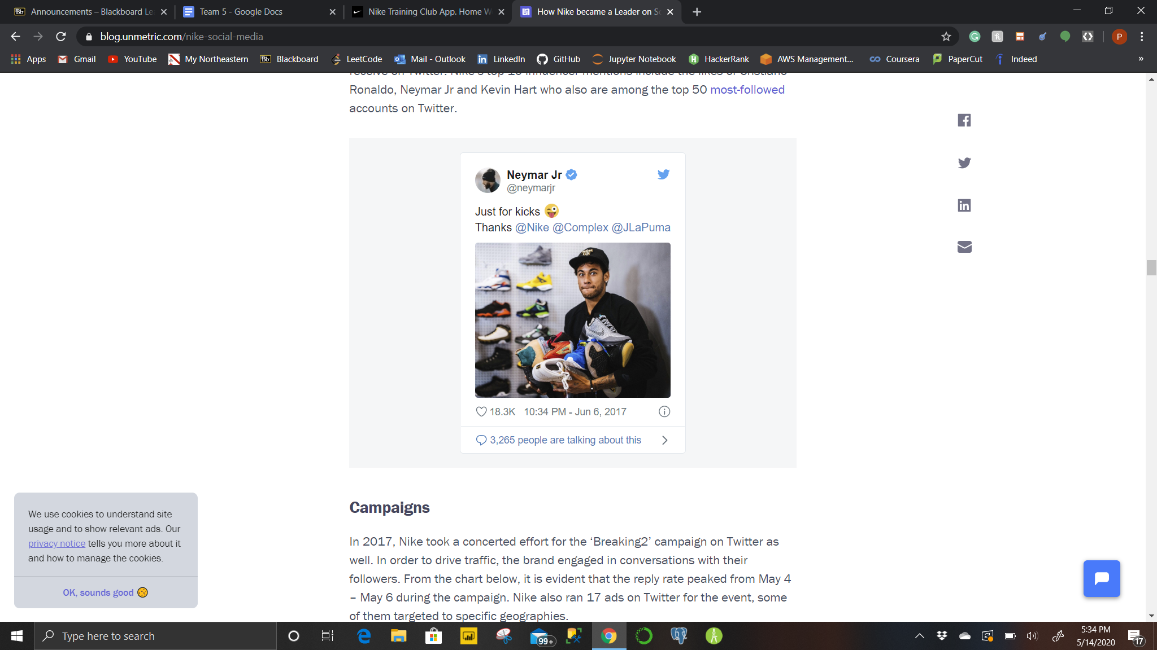

**Search**

* They have a search bar through which a customer can go to a particular category of product then based on the filters they can narrow down their search.
* Customers can also directly search for a particular product through the search bar which will navigate them directly to the product and later allow them to select the size and color.

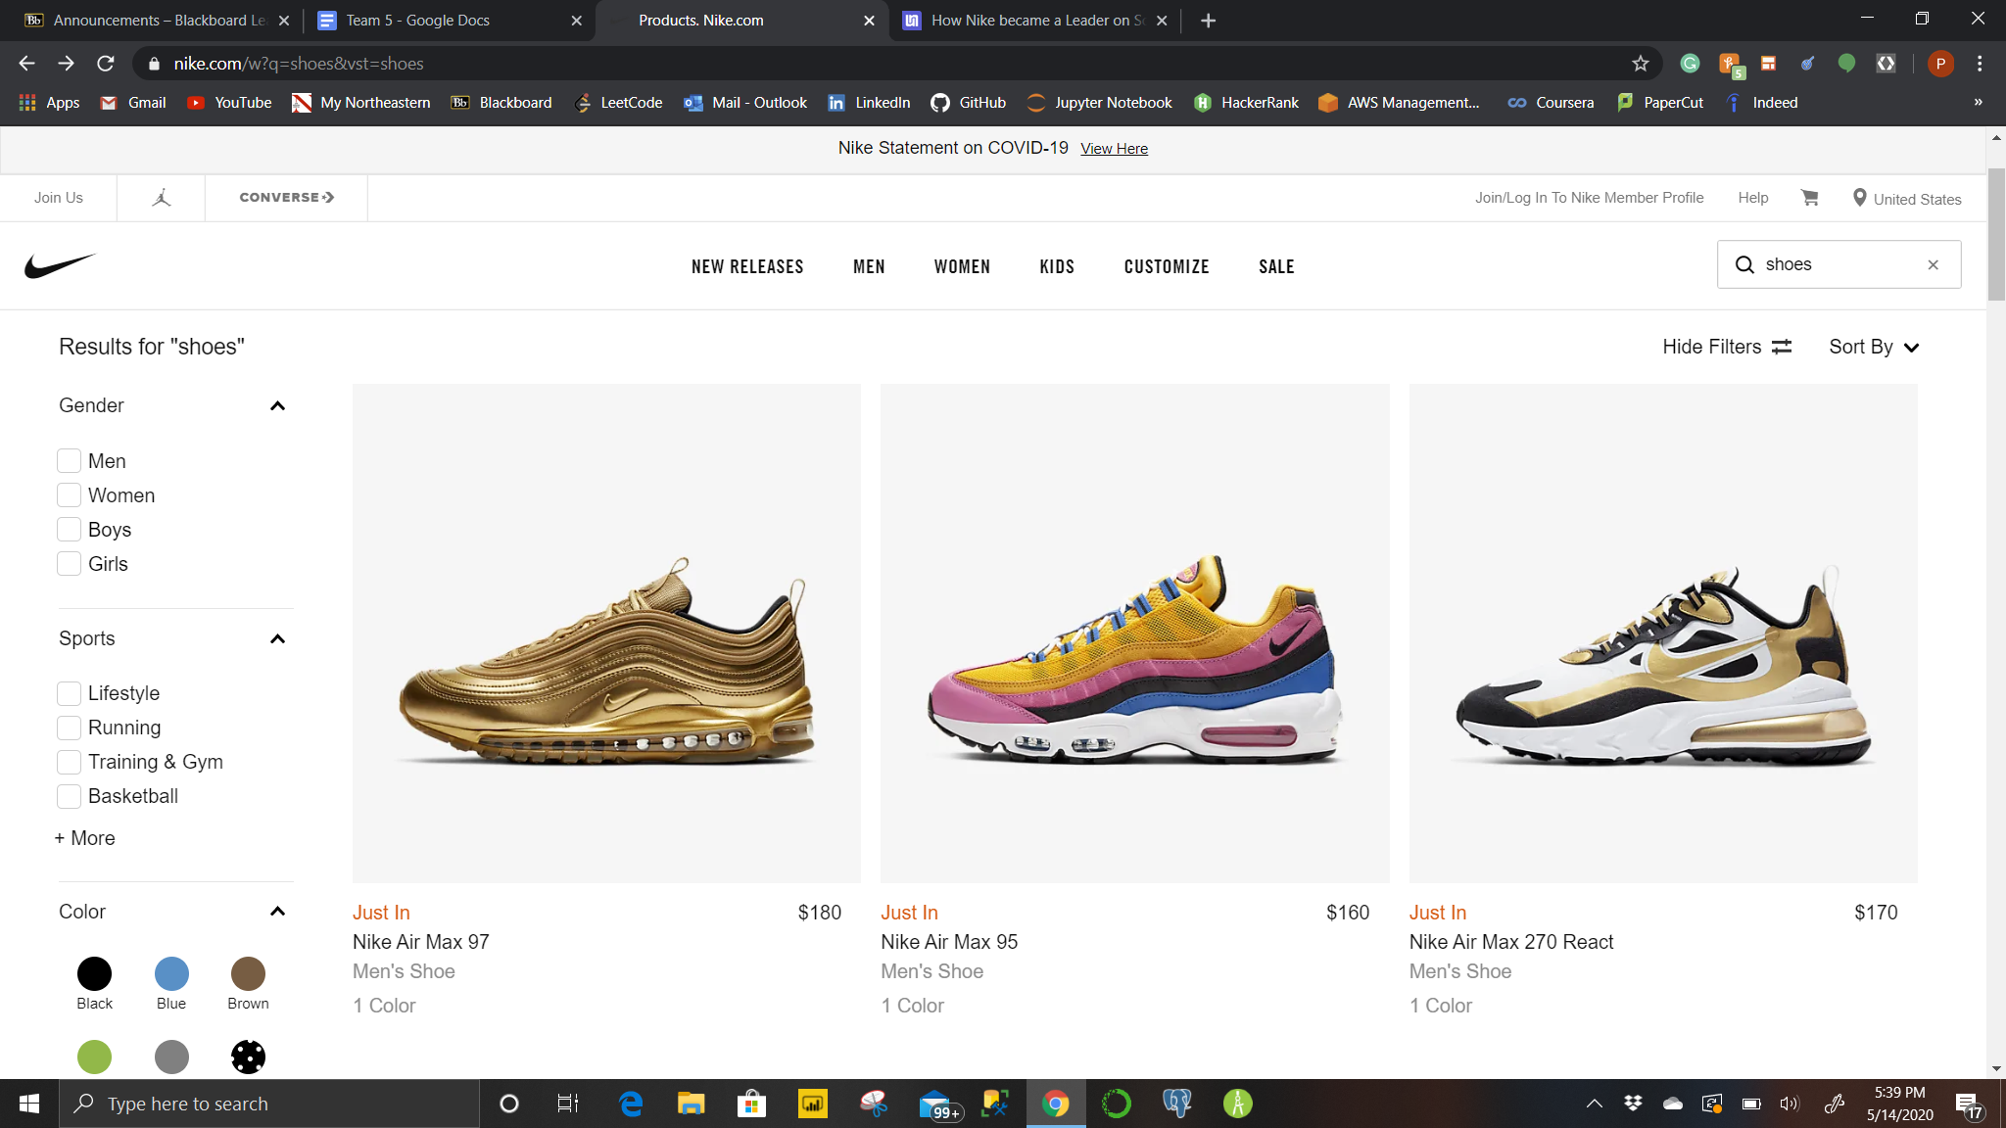

**Recommendations**

* Whenever a customer is trying to buy some product, for example a pair of shoes, it would also show the customer other shoes of similar type in the “You might also like” section.
* If the customer is trying to buy from a clothing category a shirt or a t-shirt, the site would recommend matching shoes, shorts and tracks in the “You might also like” section.

**Pricing**

* Pricing of every product is done based on the latest trend and brand which is trending.
* New releases are always priced higher than the previous ones and few branded products within the Nike site like Jordan shoes are priced higher than normal sports shoes.

**Assortment**

* Nike makes an assortment for its products based on different categories like Running, Basketball, Soccer, Golf etc, for every category it has different types of products sorted according to the customer interest
* It also has an assortment that has a collection of all conditions gear which provides all athletic apparel and sports gear for all climates.

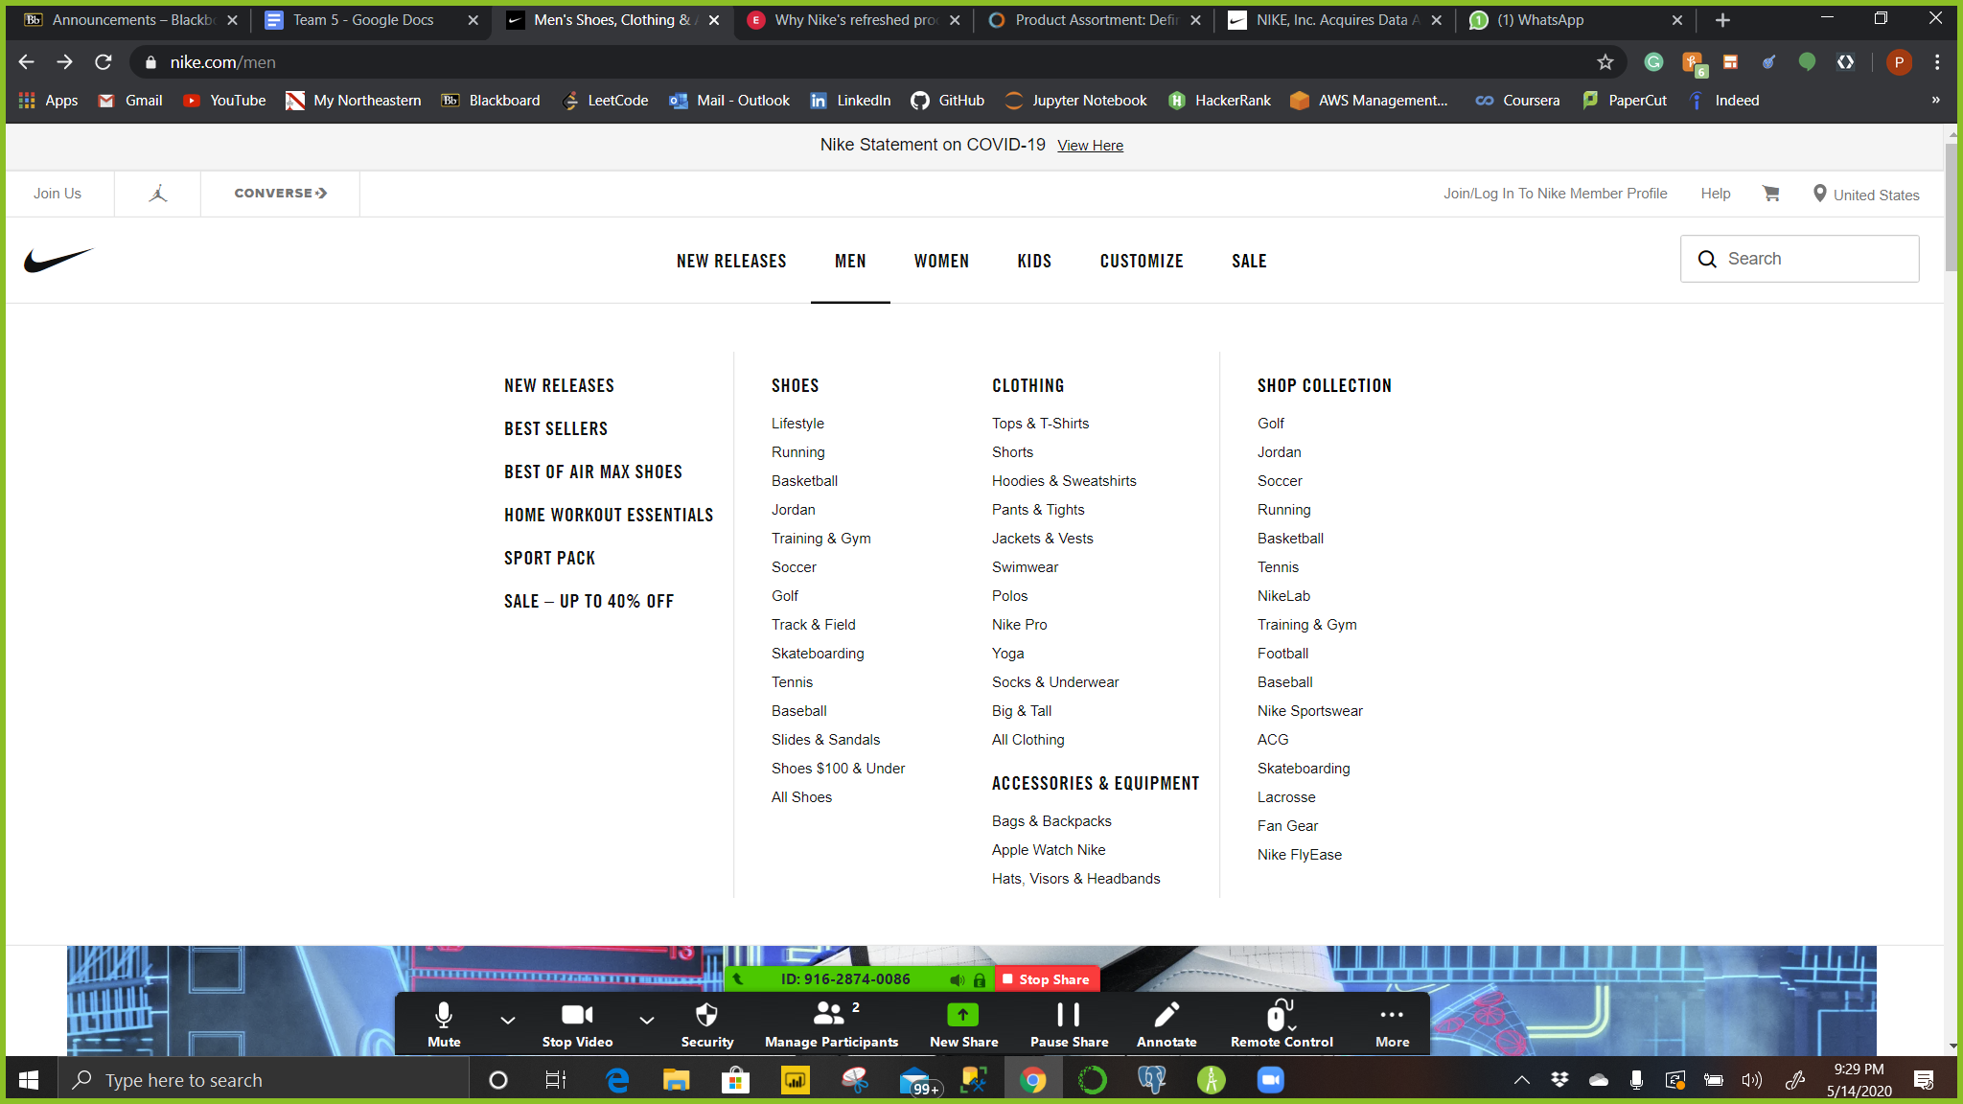

# **What datasets do you think you will need to build these algorithmic services? How frequently will data change?**

**Datasets**

* Site Navigation and search historical data of a customer helps to choose and understand the specific pattern.
* Purchasing history of a customer helps us to make future recommendations and specific offers.
* Customer or member record helps to get their contact details to provide them details about the latest product, offers and discounts.

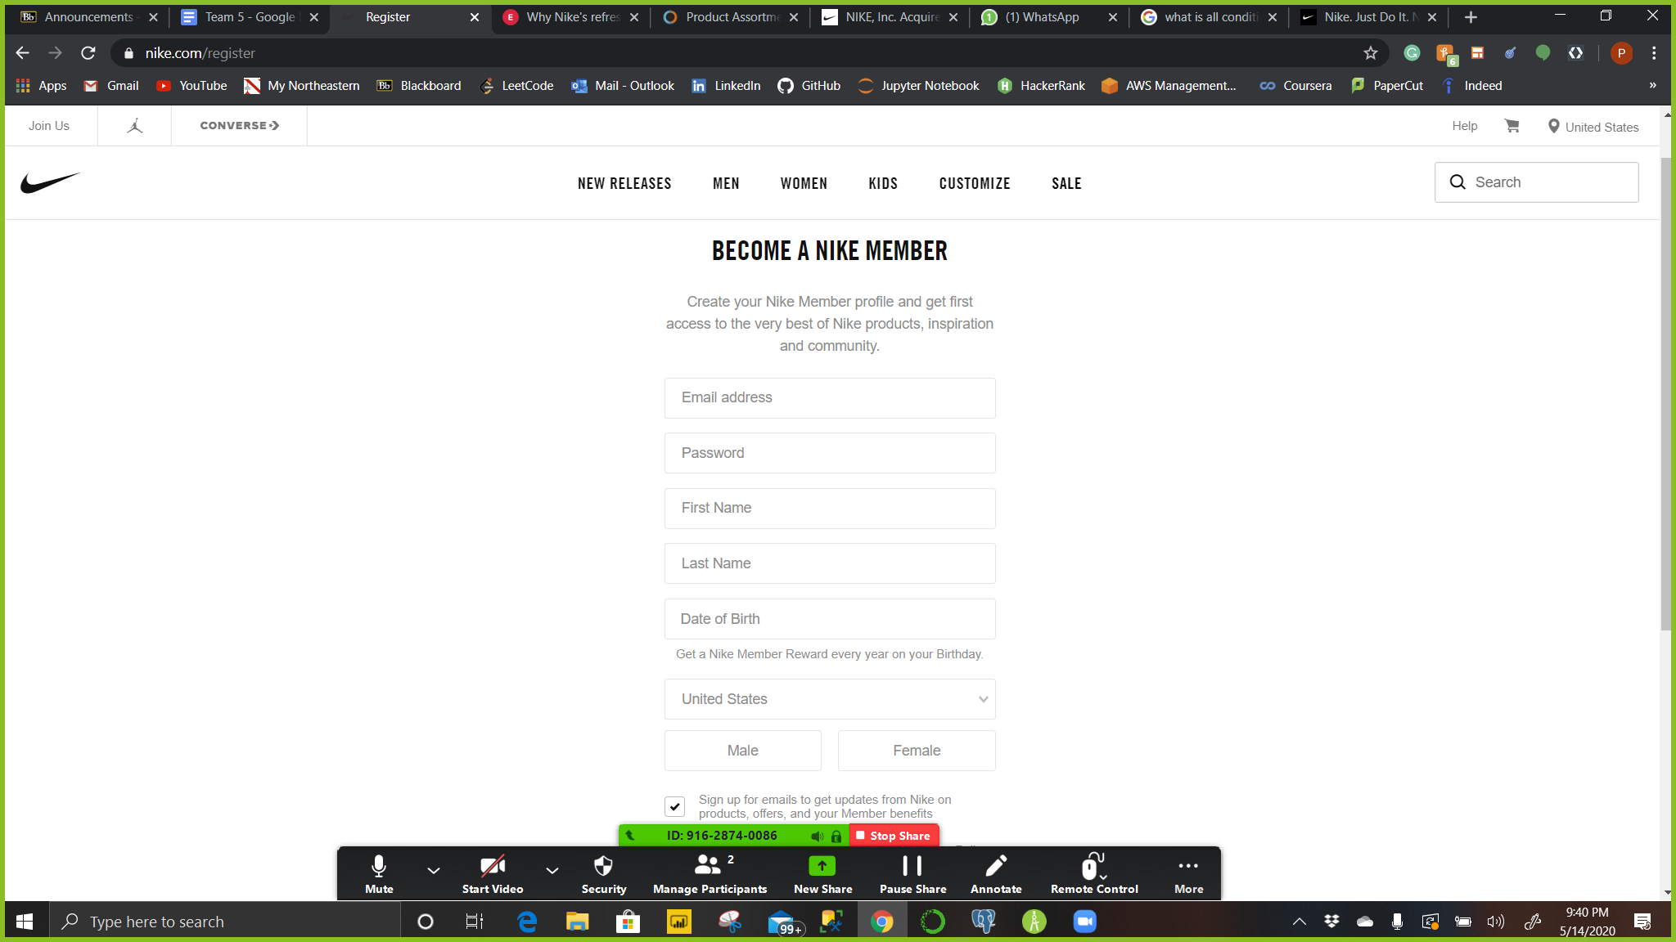

**Frequency of Data Change**

* Site Navigation and search historical data are updated instantaneously and depend on the site traffic.
* Purchase history data gets updated as soon as a new purchase is placed by a customer.
* Customer directory changes, where there is any update made by the customer or when a new member gets added to the directory.

# **How would you store these datasets?**

**Storage of data**

* Nike’s success is due to the extensive collection of data that Nike collects through Nike plus website which collects data of its customers and their daily routine which they then use for research of new products.
* Data storage is a critical part of business, Nike uses DynamoDB for storing its data. DynamoDB is a NoSQL data store because of its simple scaling and low operational burden.
* DynamoDB tables are designed around items (“rows” in a typical database), attributes (“columns”) and the key schema. The item key consists of a hash key and an optional range key, which forms a fixed key schema.
* Along with DynamoDB, Nike also uses AWS for taking care of data storage and query scalability with a simple to use API and model.

# **Review the jobs/career site and search for Data/ Data science positions (**[**https://jobs.nike.com/job/00473203?from=job%20search%20funnel**](https://jobs.nike.com/job/00473203?from=job%20search%20funnel)**). After review of the site, what technologies and programmatic services is the company using?**

**Data Scientist**

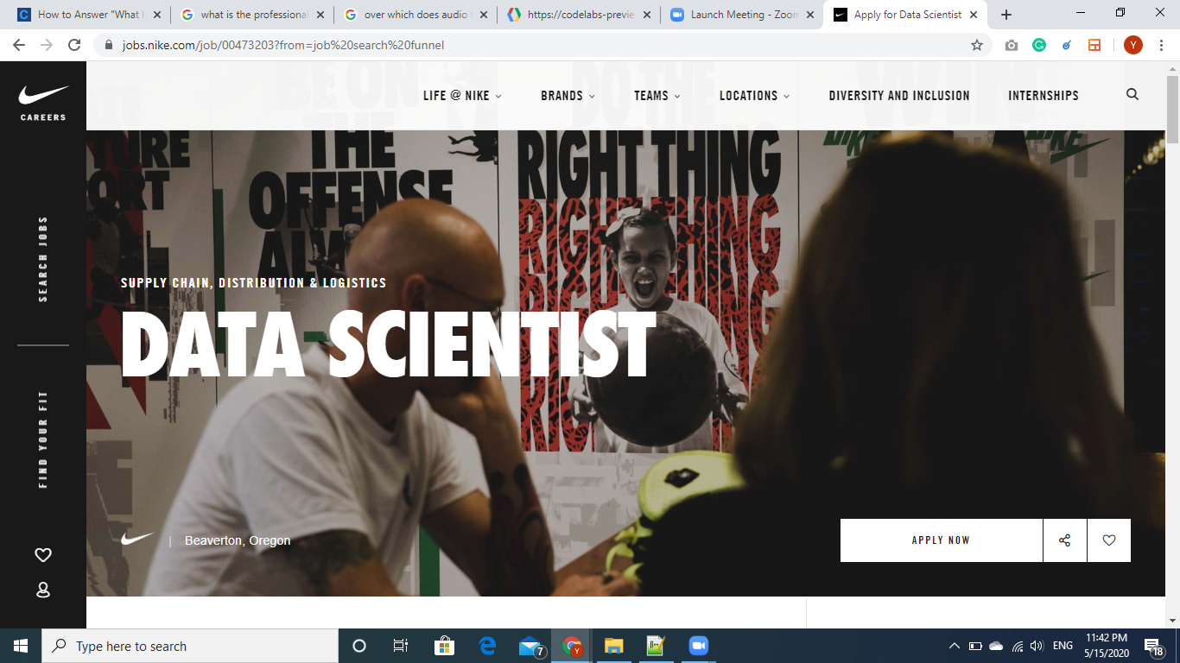

After going through the website, Nike uses a proprietary combination of computer vision, data science, machine learning, artificial intelligence and recommendation algorithms to find your right fit.

**Few of them are,**

**Value capture**

* Nike has improved its customer acquisition and retention by identifying which customers to target and predicting the right time to target them

**Operating model**

* The company’s ability to make predictions relies on the volume and quality of data that it collects.
* This is achievable only if Nike reaches out to its customers directly for both sales and marketing channels.

# **How is the company tracking visitors?**

Company is using following techniques in their website to track visitors :

**Google Analytics**

* Google Analytics is a [web analytics](https://en.wikipedia.org/wiki/Web_analytics) service offered by [Google](https://en.wikipedia.org/wiki/Google) that tracks and reports website traffic, currently as a platform inside the Google Marketing Platform brand.
* Google analytics is used to [track](https://en.wikipedia.org/wiki/Web_tracking) website activity such as [session](https://en.wikipedia.org/wiki/Session_(web_analytics)) duration, pages per session, [bounce rate](https://en.wikipedia.org/wiki/Bounce_rate) etc. of individuals using the site, along with the information on the source of the traffic.
* Google Analytics analysis can identify poorly performing pages with techniques such as funnel visualization, where visitors came from ([referrers](https://en.wikipedia.org/wiki/Referrer)), how long they stayed on the website and their geographical position.

**Facebook pixel**

* The Facebook pixel is code that you place on your website.
* It works by placing and triggering cookies to track users as they interact with your website and your Facebook ads.
* The Facebook pixel provides important information you can use to create better Facebook ads, and better target your ads. Facebook tracking pixel data helps ensure your ads are seen by the people who are most likely to take your desired action.